Assalamualaikum everyone

Thank you For given me a floor to presentation. We shall start with a brief introduction to software testing and then we will see why software testing is important, next up

we will see who does do the software testing and then we will move on with six different phrases involved in a software testing life cycle.

so lets get started.

What is software testing ?: Software Testing Life cycle (STLC) means is a testing strategy performed by the testing team ensuring that the application runs without any failure & also ensure the quality standards are met by the requirement.

STLC mostly concerned with how the software feature and function are work and identifies any defect to produce a quality product and also process of verifying and validating a software product.

Who does testing ?: this software testing so far we have the software testers , project lead or manager then we have software developer and also we have a end users that perform the software testing before any software application is developed.

AS a software tester we have some responsibilities:

we need to clear understand the apps and programmed from the stakeholder and domain how the apps will work, is it understandable or testable or not. Writing a test case and finding a bug/defect.

So now that we know what is software testing and who performs software testing.

Lets move on to STLC . in STLC process each activities is carried out in a planned and systematic way and each phrases has different goals and deliverable.

Different type of Software life cycle are:

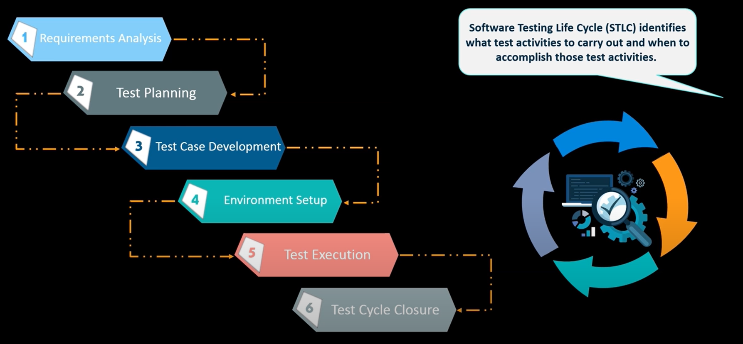

Requirement Analysis: QA Analysts/ Testers actively analyze requirements after the documents are ready by Business Analysts (BA).

Requirements are analyzed based on the following criteria:

• Clear

• Consistence, and

• Testable

requirement are either functional or non functional.

Test Planning Test Case Design: testers should review and contribute to test plans, as well as analyzing, reviewing requirements and design document and GUI.

Writing the test cases based on criteria.when test plan completed the QA team can start with test cases development activities.in the test planned test estimation test scope test strategy are documented in the test plan and it can be reviewed by management team and reused for other project.

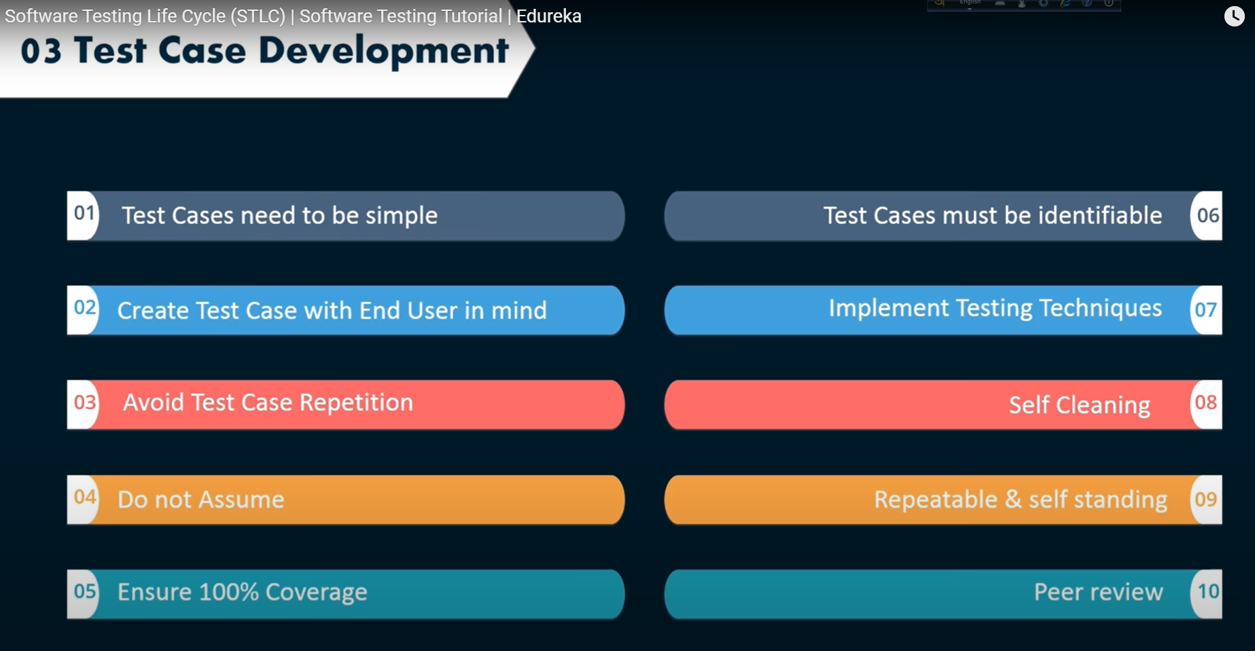

Test environment Set up: A testing environment is a setup of software and hardware for the testing teams to execute test cases. test environment can be validated by smoke testing,

and performed by the QA team,and preparation of test data.

There is two kind of Testing Environment:

1. QA Environment

2. Development environment

Ans: smoke testing - high level testing before functional testing starts to make sure, all the functionality match according to requirements. It is a initial level of testing before testing new functionality. smoke testing is every initial level testing we do before goes to production.

Test Execution: The real validation of product / AUT starts here. specified requirements/ test cases prepared.Note − In SIT testing, the QA team tries to find as many defects as possible to ensure the quality. The main objective here is finding bugs as many as possible.

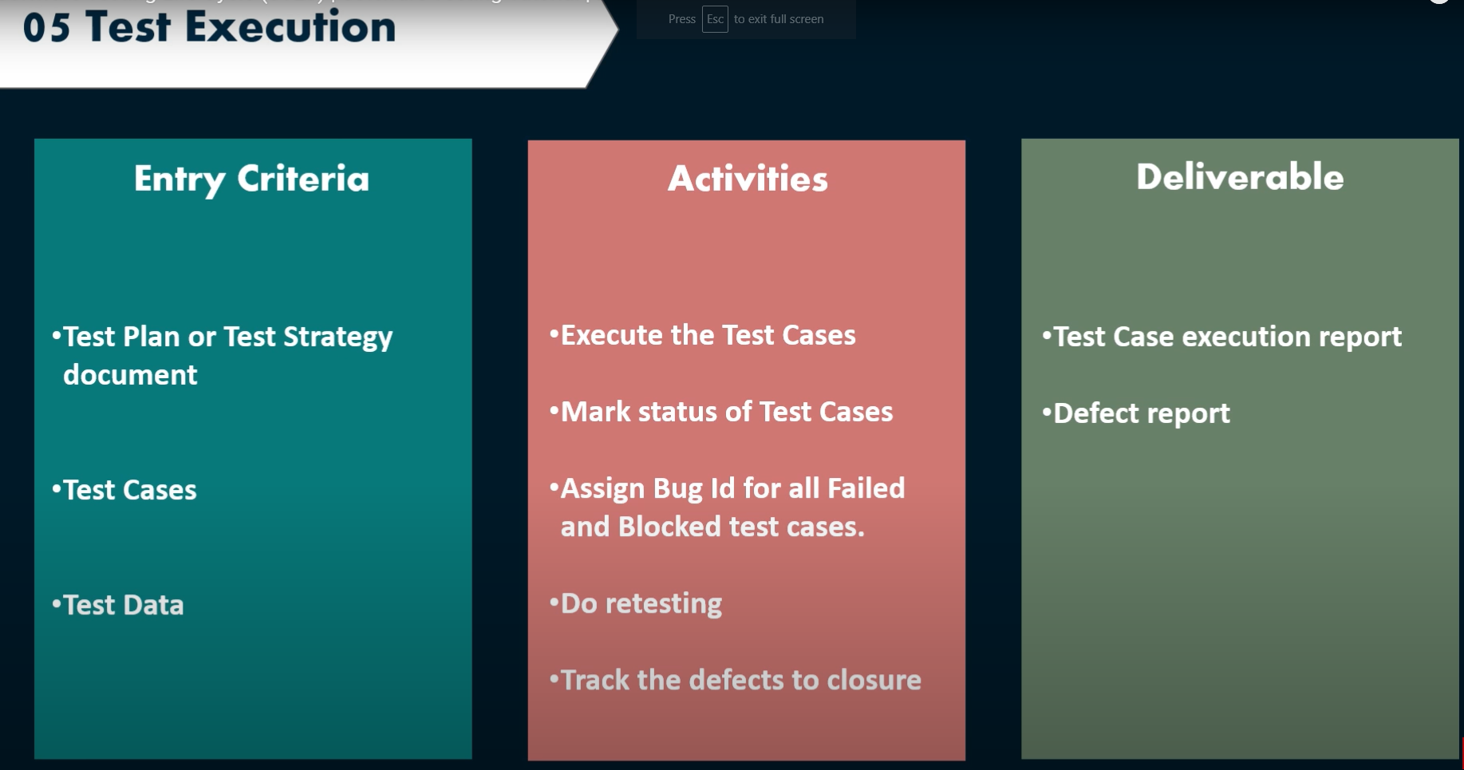

Test Closer: After Test execution if we don’t find any bug or defect it will goes to UAT User Acceptance Testing. but if we find any defect it will go to the Defect Reporting.

Test cycle clouser has some points

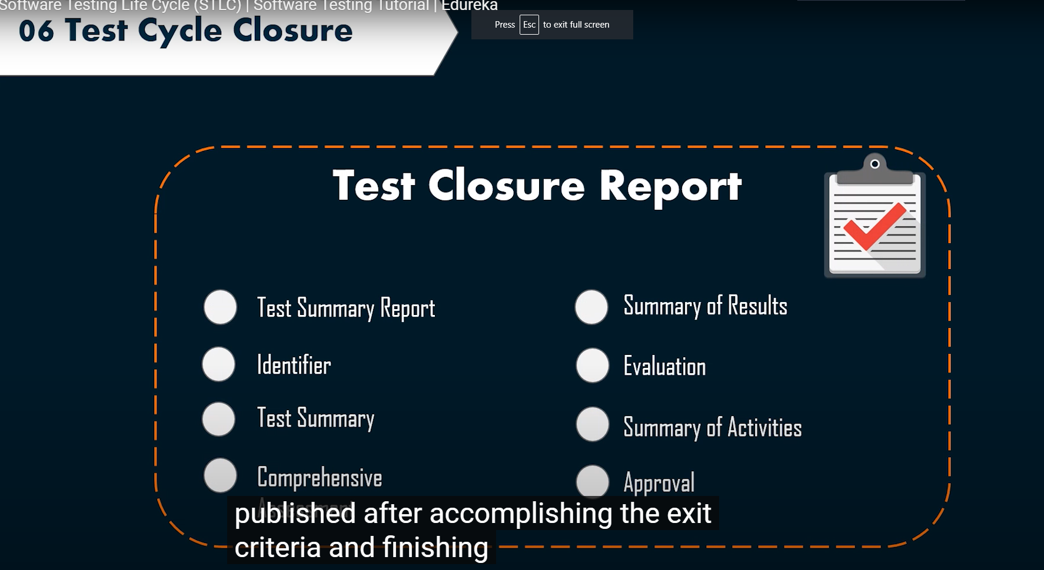

I would like to call Farhana to give her presentation. Thank you